یہ نفسیات کے نوٹس میں نے خود آسان اور سادہ زبان میں تیار کیے ہیں۔ اگر ان سے کسی کو فائدہ ہو تو مجھے اپنی دعاؤں میں یاد رکھیے گا، اور گیارہ مرتبہ درودِ ابراہیمی بطور تحفہ ضرور پڑھ دیجیے گا۔

اللہ تعالیٰ ہم سب کو علمِ نافع عطا فرمائے، آمین۔

محمد فہد شاہد (بی ایس سائیکلوجی-7سمسٹر)

📘 CHAPTER 1: INTRODUCTION TO EXCEL

🖥️ 1. What is Excel?
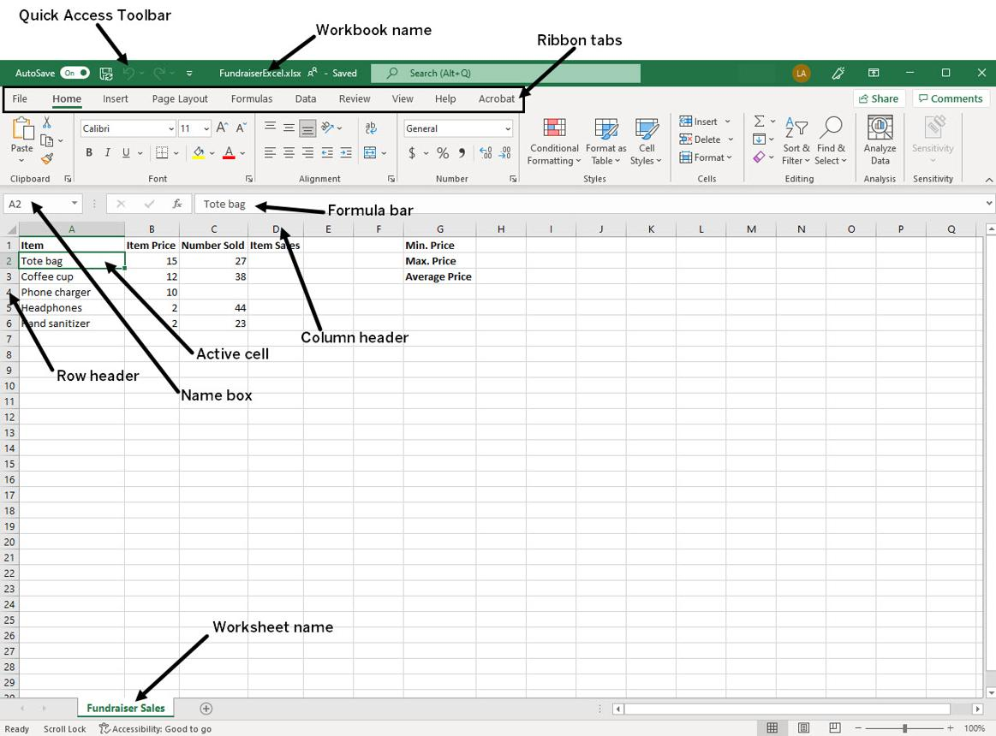
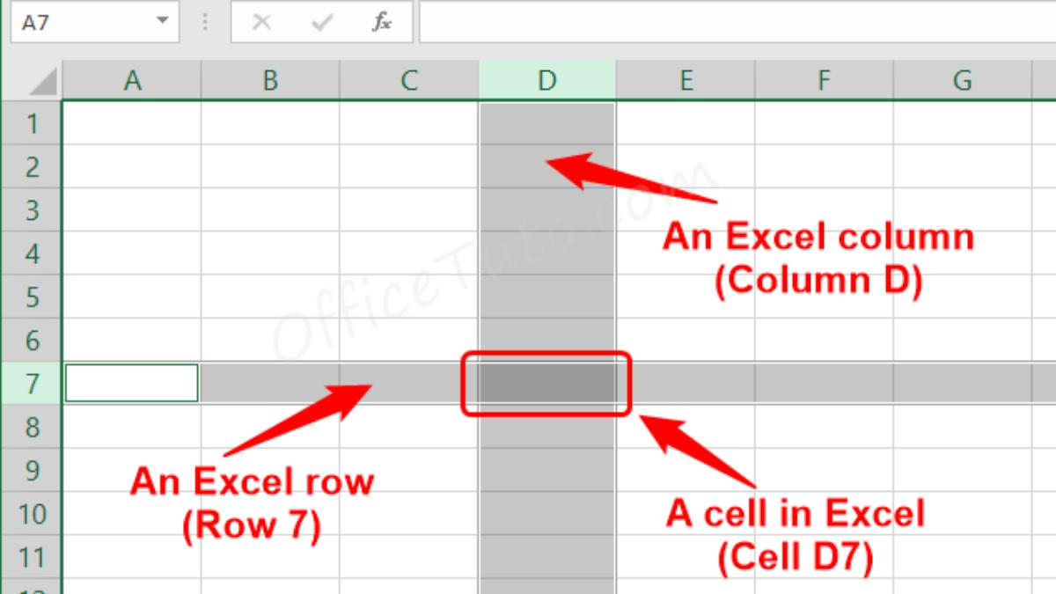
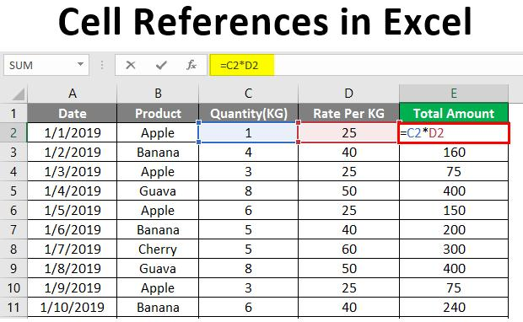
7

✅ Simple Definition:
Excel is a spreadsheet software used to:
- Store data
- Perform calculations
- Analyze data
- Create charts/graphs
👉 Think Excel like a digital notebook with automatic calculator

📊 2. Structure of Excel

🔹 Workbook
- Complete Excel file
- Example: Marks.xlsx

🔹 Worksheet
- Sheet inside workbook
- Like pages in notebook

🔹 Rows & Columns
- Rows → Horizontal (1,2,3…)
- Columns → Vertical (A,B,C…)

🔹 Cell
- Intersection of row & column
- Example: A1, B2
👉 Memory Trick:
👉 Cell = Column + Row (A1, B5)

🧾 3. Types of Data in Excel
Type | Example | Explanation
Label | Name | Text
Value | 100 | Numbers
Formula | =A1+B1 | Calculation

➗ 4. Formulas in Excel

✅ Definition:
Formula = Calculation written in Excel
👉 Always start with =

Example:
=A1 + B1

⚙️ 5. Operators in Excel

🔹 Arithmetic Operators
Operator | Meaning
+ | Add
- | Subtract
* | Multiply
/ | Divide
^ | Power

🔹 Relational Operators
Operator | Meaning
> | Greater
< | Less
= | Equal

🧠 6. Order of Precedence (VERY IMPORTANT)
👉 Excel follows order:
- ( ) Brackets
- ^ Power

  - /

👉 Trick: BODMAS

Example:
=2+3*5 = 17 (not 25)

🎯 7. Precision vs Display
👉 Excel stores full value but shows rounded
Example:
Actual | Display
0.125 | 0.13

📅 8. Dates in Excel
- Excel stores date as numbers
- Used in calculations
Example:
=A2 - A1
👉 Gives number of days

🧑‍💻 9. Excel Practical (STEP BY STEP)

➤ Step 1: Open Excel
Start → Excel

➤ Step 2: Enter Data
Type in cells

➤ Step 3: Formula
Type:
=A1+B1

➤ Step 4: Save
Ctrl + S

📊 10. Important Functions
Function | Use | Example
SUM | Add | =SUM(A1:A5)
AVERAGE | Mean | =AVERAGE(A1:A5)
COUNT | Count numbers | =COUNT(A1:A5)

🎯 11. Exam Tips
✔ Always write formula with =
✔ Learn shortcuts
✔ Practice daily
✔ Use brackets to avoid mistakes

🧠 MCQs (Chapter 1 – Detailed)

Q1. Excel is:
A) Word processor
B) Spreadsheet software ✅
C) Browser

Q2. Intersection of row and column is:
A) Table
B) Cell ✅
C) Sheet

Q3. Formula starts with:
A) +
B) = ✅
C) *

Q4. Which is NOT operator?
A) +
B) *
C) % (in basic Excel context) ✅

Q5. BODMAS means:
A) Order of operations ✅
B) Formula type
C) Function

Q6. Workbook is:
A) Page
B) File ✅
C) Cell

Q7. Row is:
A) Vertical
B) Horizontal ✅

Q8. Column is:
A) Horizontal
B) Vertical ✅

Q9. SUM function is used for:
A) Multiply
B) Add ✅

Q10. Excel converts date into:
A) Text
B) Number ✅

✏️ SHORT QUESTIONS (WITH ANSWERS)

Q1. What is Excel?
👉 Excel is a spreadsheet software used to store and analyze data.

Q2. What is a cell?
👉 A cell is the intersection of row and column.

Q3. What is formula?
👉 A formula is a calculation starting with =.

Q4. What is workbook?
👉 Excel file is called workbook.

Q5. What is worksheet?
👉 Sheet inside workbook.

📝 LONG QUESTIONS (WITH ANSWERS)

Q1. Explain Excel interface
👉 Excel interface includes:
- Ribbon
- Formula bar
- Rows & columns
- Cells

Q2. Explain types of data
👉 Data types:
- Label (text)
- Value (numbers)
- Formula (calculation)

Q3. Explain operators
👉 Operators perform calculations like +, -, *, /

🎯 PRACTICAL QUESTION (IMPORTANT)
👉 Create Excel sheet:
- Enter 5 numbers
- Find sum and average

🧠 MEMORY TRICKS
✔ Cell = Column + Row
✔ Formula = must start with equal= sign
✔ BODMAS for order

📘 CHAPTER 2: MEASURES OF CENTRAL TENDENCY

📊 What is Central Tendency?
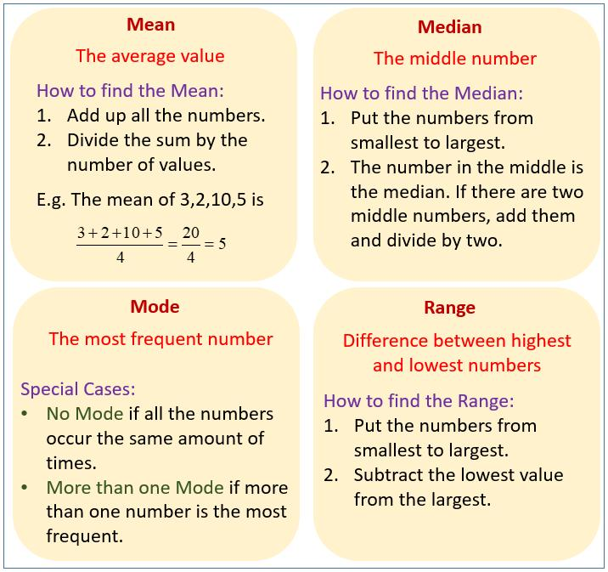
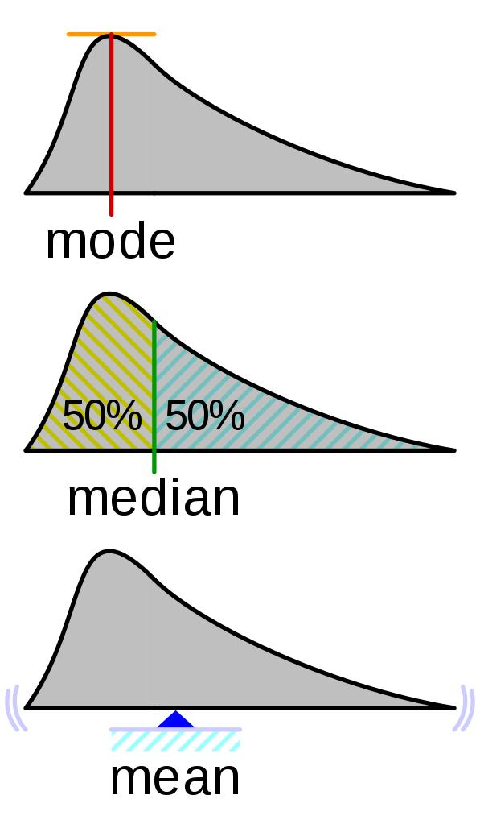
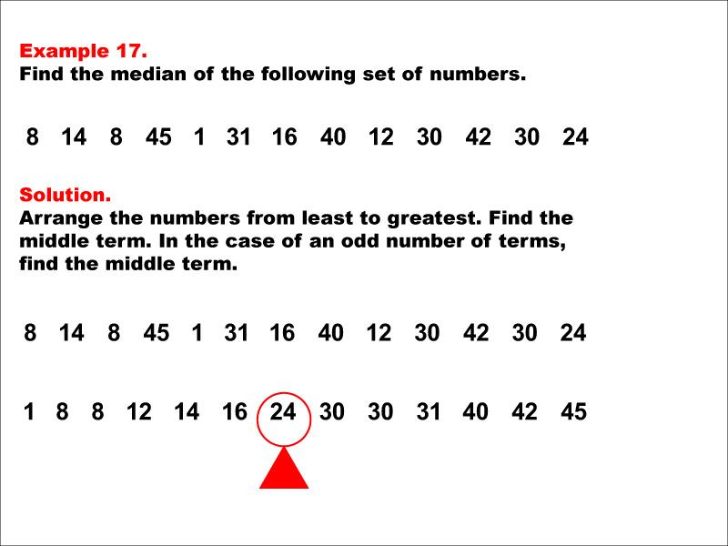
7

✅ Simple Definition:
Central tendency means center or average value of data
👉 It tells:
“Data ka middle point kya hai?”

📌 Types of Central Tendency
- Mean (Average)
- Median (Middle value)
- Mode (Most repeated value)

🔹 1. MEAN (AVERAGE)

📐 Formula:
Xˉ=∑Xn\bar{X} = \frac{\sum X}{n}Xˉ=n∑X​

✅ Simple Explanation:
👉 Add all values ÷ total numbers

📊 Example:
Data: 2, 4, 6, 8
Step 1: Sum = 2+4+6+8 = 20
Step 2: n = 4
Mean = 20 ÷ 4 = 5

⚠️ Important Point:
👉 Mean is affected by outliers (extreme values)
Example:
2, 3, 4, 100 → Mean becomes very large ❌

🧑‍💻 Mean in Excel

Steps:
- Enter data in cells (A1:A5)
- Click empty cell
- Type:
=AVERAGE(A1:A5)

🔹 2. MEDIAN

✅ Definition:
Median = middle value after sorting data

📊 Steps:

Case 1: Odd numbers
Data: 1, 3, 5
👉 Median = 3

Case 2: Even numbers
Data: 1, 2, 3, 4
👉 Median = (2+3)/2 = 2.5

⚠️ Important:
✔ Not affected by outliers
✔ Best for skewed data

🧑‍💻 Median in Excel
=MEDIAN(A1:A5)

🔹 3. MODE

✅ Definition:
Mode = most repeated value

📊 Example:
Data: 2, 3, 3, 5, 6
👉 Mode = 3

⚠️ Important Points:
✔ Can be:
- No mode
- One mode
- More than one mode

🧑‍💻 Mode in Excel
=MODE(A1:A5)

📊 COMPARISON TABLE
Measure | Meaning | Affected by Outliers
Mean | Average | Yes ❌
Median | Middle | No ✅
Mode | Most frequent | No ✅

🎯 EXAM TIPS (VERY IMPORTANT)
✔ If outliers → use Median
✔ Normal data → use Mean
✔ Repetition → use Mode

🧠 MEMORY TRICK
👉 Mean = Average
👉 Median = Middle
👉 Mode = Most

📊 PRACTICAL NUMERICAL (VERY IMPORTANT)

Q: Find Mean, Median, Mode
Data: 5, 7, 8, 8, 10

Solution:

Mean:
Sum = 38
n = 5
Mean = 38/5 = 7.6

Median:
Middle value = 8

Mode:
Most frequent = 8

🧠 MCQs (LOTS – WITH ANSWERS)

Q1. Mean is:
A) Middle
B) Average ✅
C) Frequency

Q2. Median is:
A) Average
B) Middle value ✅
C) Maximum

Q3. Mode is:
A) Least value
B) Most repeated value ✅

Q4. Which is affected by outliers?
A) Mean ✅
B) Median
C) Mode

Q5. Median of 1,2,3,4 is:
A) 2
B) 2.5 ✅
C) 3

Q6. Mode of 2,2,3,4 is:
A) 2 ✅
B) 3
C) 4

Q7. Mean formula is:
A) Sum/n ✅
B) Max-min
C) Frequency

Q8. Median requires:
A) Sorting data ✅
B) Multiplying
C) Graph

Q9. If no value repeats:
A) Mode exists
B) No mode ✅

Q10. Best for skewed data:
A) Mean
B) Median ✅

✏️ SHORT QUESTIONS (WITH ANSWERS)

Q1. Define Mean
👉 Mean is sum of values divided by total numbers

Q2. Define Median
👉 Median is middle value of sorted data

Q3. Define Mode
👉 Mode is most repeated value

Q4. Which measure is not affected by extreme values?
👉 Median

📝 LONG QUESTIONS (WITH ANSWERS)

Q1. Explain Mean, Median, Mode
👉 Mean: Average value
👉 Median: Middle value
👉 Mode: Most frequent value

Q2. Compare Mean and Median
👉 Mean affected by outliers
👉 Median not affected

Q3. Explain importance of central tendency
👉 Helps to:
- Summarize data
- Understand distribution
- Make decisions

📊 EXCEL PRACTICAL QUESTION
👉 Enter data: 10, 20, 30, 40
Find:
- Mean
- Median
- Mode

🎯 FINAL QUICK REVISION
✔ Mean = Sum ÷ n
✔ Median = Middle
✔ Mode = Most frequent

📘 CHAPTER 3: MEASURES OF DISPERSION

📊 What is Dispersion?
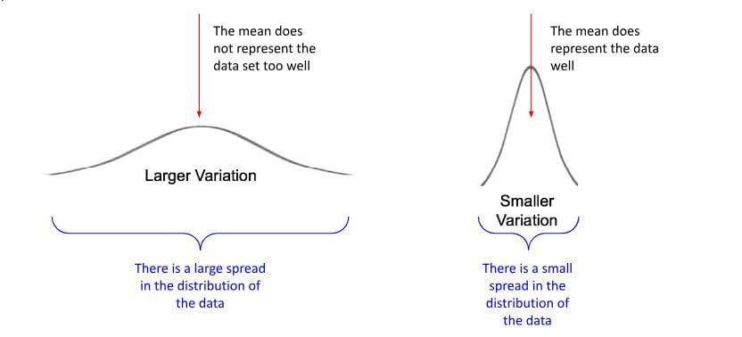
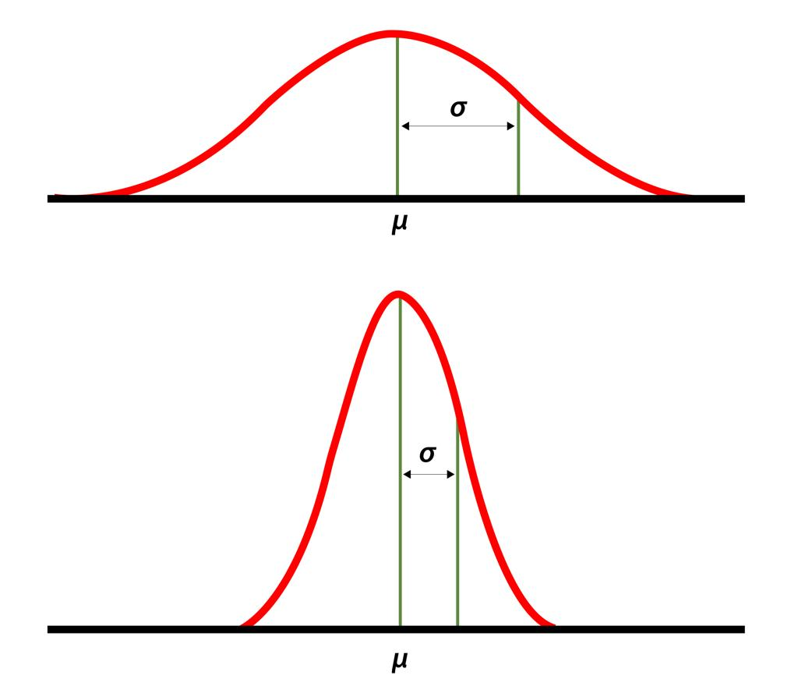
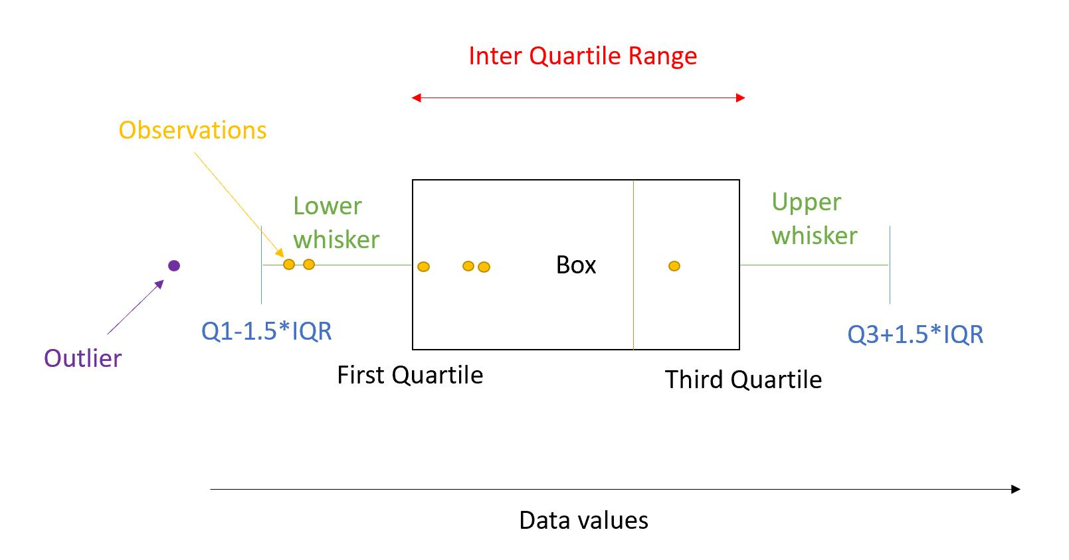
6

✅ Simple Definition:
Dispersion means how much data is spread out
👉 It tells:
“Data ek jaga close hai ya phaila hua hai?”

📌 Why Dispersion is Important?
✔ Shows variability
✔ Helps compare datasets
✔ Used in decision making
✔ Important in exams

📊 TYPES OF DISPERSION
- Range
- Variance
- Standard Deviation
- Interquartile Range (IQR)
- Coefficient of Variation (CV)

🔹 1. RANGE

📐 Formula:
Range=Xmax−XminRange = X_{max} - X_{min}Range=Xmax​−Xmin​

✅ Explanation:
👉 Difference between highest and lowest value

📊 Example:
Data: 2, 5, 8, 10
Max = 10
Min = 2
Range = 10 – 2 = 8

⚠️ Disadvantages
❌ Uses only 2 values
❌ Affected by outliers

🧠 Trick:
👉 “Range = Big – Small”

🔹 2. VARIANCE

📐 Formula:
s2=∑(X−Xˉ)2n−1s^2 = \frac{\sum (X - \bar{X})^2}{n-1}s2=n−1∑(X−Xˉ)2​
spreadspreadspread
nnn
xˉ≈−0.01,;s2≈1.934\bar{x}\approx -0.01,; s^2\approx 1.934xˉ≈−0.01,;s2≈1.934
xbar=-0.01s^2 ~ 1.934

✅ Explanation:
👉 Average of squared differences from mean

📊 Example:
Data: 2, 4, 6
Mean = 4
Steps:
(2–4)² = 4
(4–4)² = 0
(6–4)² = 4
Sum = 8
Variance = 8/(3-1) = 4

⚠️ Important:
✔ Square is used to remove negatives

🔹 3. STANDARD DEVIATION (MOST IMPORTANT)

📐 Formula:
s=∑(X−Xˉ)2n−1s = \sqrt{\frac{\sum (X - \bar{X})^2}{n-1}}s=n−1∑(X−Xˉ)2​​
spreadspreadspread
nnn
xˉ≈−0.01,;s2≈1.934\bar{x}\approx -0.01,; s^2\approx 1.934xˉ≈−0.01,;s2≈1.934
xbar=-0.01s^2 ~ 1.934

✅ Explanation:
👉 Square root of variance
👉 Shows real spread in same unit

📊 Example:
Variance = 4
SD = √4 = 2

🎯 Interpretation:
SD Value | Meaning
Small | Data close
Large | Data spread

🧠 Trick:
👉 “SD = Spread Distance”

🔹 4. INTERQUARTILE RANGE (IQR)

📐 Formula:
IQR = Q3 – Q1

✅ Explanation:
👉 Middle 50% data

📊 Example:
Data: 1,2,3,4,5,6,7
Q1 = 2
Q3 = 6
IQR = 6 – 2 = 4

⚠️ Advantage:
✔ Not affected by outliers

🔹 5. COEFFICIENT OF VARIATION (CV)

📐 Formula:
CV=sXˉ×100CV = \frac{s}{\bar{X}} \times 100CV=Xˉs​×100

✅ Explanation:
👉 Shows variation in percentage

📊 Example:
Mean = 50
SD = 5
CV = (5/50)×100 = 10%

🎯 Use:
✔ Compare different datasets

🧑‍💻 EXCEL PRACTICAL (VERY IMPORTANT)

Step-by-Step:

➤ Enter Data in Column A

➤ Range:
=MAX(A1:A10)-MIN(A1:A10)

➤ Variance:
=VAR(A1:A10)

➤ Standard Deviation:
=STDEV(A1:A10)

🎯 EXAM TIPS
✔ SD is MOST important
✔ Always show steps
✔ Remember formulas
✔ Practice numericals

🧠 MEMORY TRICKS
✔ Range = Max – Min
✔ Variance = squared differences
✔ SD = √variance
✔ CV = percentage

📊 SOLVED NUMERICAL (IMPORTANT)

Q: Find Range, Variance, SD
Data: 4, 6, 8

Step 1: Mean
= (4+6+8)/3 = 6

Step 2: Variance
(4-6)² = 4
(6-6)² = 0
(8-6)² = 4
Sum = 8
Variance = 8/2 = 4

Step 3: SD
√4 = 2

Step 4: Range
8 – 4 = 4

🧠 MCQs (LOTS – EXAM LEVEL)

Q1. Range formula:
A) Max – Min ✅
B) Sum/n
C) Mean

Q2. SD is:
A) Square
B) Square root of variance ✅

Q3. Variance uses:
A) Squares ✅
B) Addition

Q4. Which is MOST important?
A) Range
B) SD ✅

Q5. IQR formula:
A) Q3 – Q1 ✅
B) Q1 – Q3

Q6. CV is:
A) Ratio
B) Percentage ✅

Q7. Small SD means:
A) Spread
B) Close data ✅

Q8. Range depends on:
A) All values
B) Only max & min ✅

Q9. Variance removes:
A) Negatives using square ✅

Q10. SD unit is:
A) Same as data ✅

✏️ SHORT QUESTIONS (WITH ANSWERS)

Q1. Define Range
👉 Difference between max and min

Q2. Define Variance
👉 Average squared deviation

Q3. Define SD
👉 Square root of variance

Q4. Define IQR
👉 Difference between Q3 and Q1

Q5. Define CV
👉 Ratio of SD to mean in %

📝 LONG QUESTIONS (WITH ANSWERS)

Q1. Explain measures of dispersion
👉 Includes:
- Range
- Variance
- SD
- IQR
- CV

Q2. Compare Range and SD
👉 Range: simple, less accurate
👉 SD: accurate, uses all values

Q3. Explain importance of SD
👉 Helps:
- Understand spread
- Compare data
- Decision making

🎯 PRACTICAL QUESTION
👉 Enter data in Excel
Find:
- Range
- Variance
- SD

🎓 FINAL REVISION
✔ Range = Max – Min
✔ Variance = squared difference
✔ SD = √variance
✔ IQR = Q3 – Q1
✔ CV = % variation

📘 CHAPTER 4: GRAPHS & DATA PRESENTATION

📊 Why Graphs are Important?
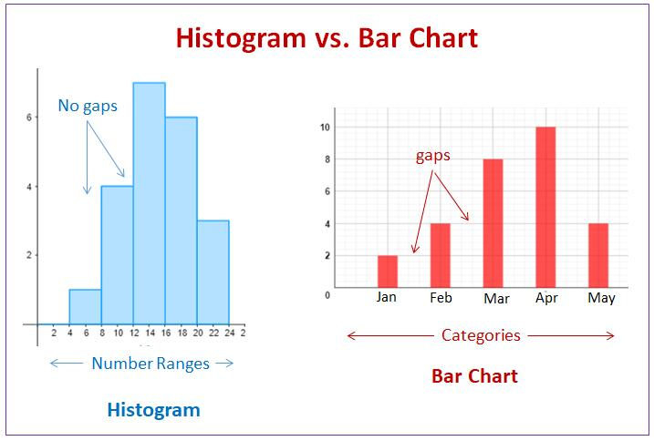
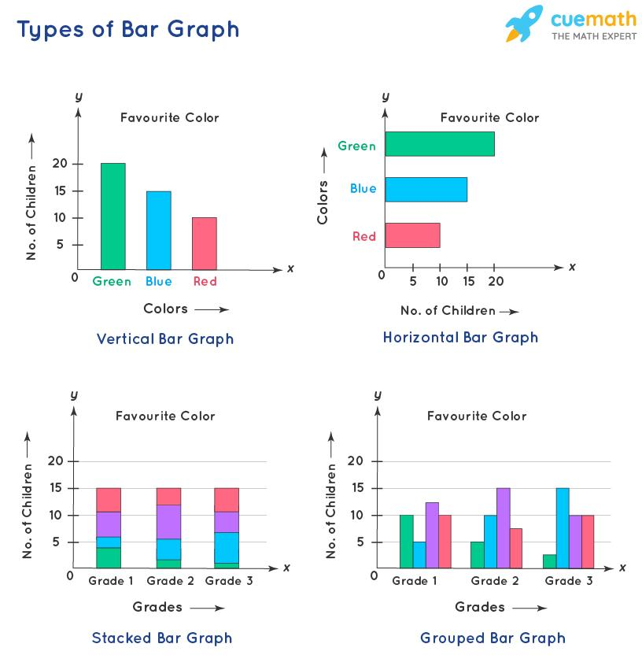
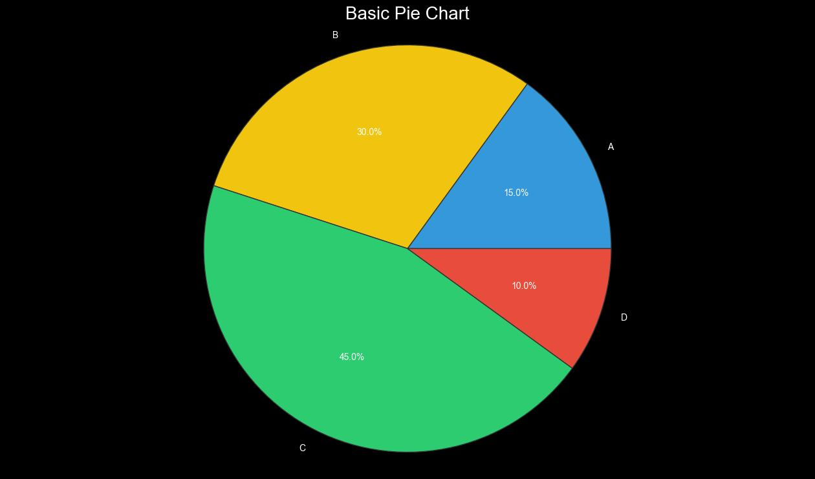
6

✅ Simple Idea:
Graphs help us:
- Understand data quickly
- Make decisions
- Compare values
👉 Instead of reading numbers, we see the data visually

📌 TYPES OF DATA PRESENTATION
- Frequency Distribution (Table)
- Histogram
- Bar Chart
- Pie Chart
- Cumulative Graph (Ogive)

🔹 1. FREQUENCY DISTRIBUTION

✅ Definition:
Table showing how many times values occur

📊 Steps to Make Table
Example Data:
12, 15, 18, 22, 25, 27, 30

Step 1: Find Range
30 – 12 = 18

Step 2: Choose classes
Example: 10–20, 20–30

Step 3: Count frequency
Class | Frequency
10–20 | 3
20–30 | 4

🎯 Important Rules
✔ Classes should not overlap
✔ Use 5–15 classes
✔ Equal width

🔹 2. HISTOGRAM

📊 Definition:
Graph using bars (no gaps) for continuous data

📌 Key Features:
✔ No space between bars
✔ X-axis = class intervals
✔ Y-axis = frequency

🎯 Example Understanding:
- Height of bar = frequency
- More height → more data

🧠 Trick:
👉 Histogram = “No Gap Graph”

🔹 3. BAR CHART

📊 Definition:
Graph using bars for categorical data

📌 Features:
✔ Bars have gaps
✔ Used for categories

📊 Example:
Color | Number
Red | 10
Blue | 5

🎯 Trick:
👉 Bar chart = “Categories + Gap”

🔹 4. PIE CHART

📊 Definition:
Circle divided into parts

📌 Features:
✔ Shows percentage
✔ Total = 100%

📊 Example:
Category | %
A | 40%
B | 60%

🎯 Trick:
👉 Pie = “Parts of whole”

🔹 5. OGIVE (CUMULATIVE GRAPH)

📊 Definition:
Graph of cumulative frequency

📌 Use:
✔ Find median
✔ Analyze distribution

🧑‍💻 EXCEL PRACTICAL (VERY IMPORTANT)

📊 Create Chart in Excel

Steps:
- Enter data
- Select data
- Click Insert tab
- Choose chart:
  - Bar
  - Pie
  - Histogram

📊 Histogram in Excel
Insert → Charts → Histogram

📊 Pie Chart
Insert → Pie Chart

📊 Bar Chart
Insert → Bar Chart

🎯 EXAM TIPS
✔ Histogram = no gaps
✔ Bar chart = gaps
✔ Pie chart = percentage
✔ Practice drawing

🧠 MEMORY TRICKS
✔ Histogram → “No Gap”
✔ Bar → “Gap”
✔ Pie → “100%”

📊 SOLVED EXAMPLE
Data: 5, 10, 15, 20
👉 Bar chart:
- X-axis = values
- Y-axis = frequency

🧠 MCQs (LOTS – EXAM LEVEL)

Q1. Histogram has:
A) Gaps
B) No gaps ✅

Q2. Bar chart is used for:
A) Continuous data
B) Categorical data ✅

Q3. Pie chart shows:
A) Frequency
B) Percentage ✅

Q4. Total of pie chart:
A) 50%
B) 100% ✅

Q5. Frequency distribution is:
A) Graph
B) Table ✅

Q6. Histogram uses:
A) Categories
B) Continuous data ✅

Q7. Ogive is:
A) Bar chart
B) Cumulative graph ✅

Q8. Bars in histogram:
A) Touch each other ✅
B) Separate

Q9. Bar chart bars:
A) Touch
B) Have gaps ✅

Q10. Graph helps:
A) Confuse
B) Understand data ✅

✏️ SHORT QUESTIONS (WITH ANSWERS)

Q1. What is histogram?
👉 Graph with no gaps for continuous data

Q2. What is bar chart?
👉 Graph with gaps for categories

Q3. What is pie chart?
👉 Circle showing percentages

Q4. What is frequency distribution?
👉 Table of frequencies

📝 LONG QUESTIONS (WITH ANSWERS)

Q1. Explain histogram, bar chart, pie chart
👉 Histogram → continuous
👉 Bar → categorical
👉 Pie → percentage

Q2. Difference between histogram and bar chart
👉 Histogram → no gaps
👉 Bar → gaps

Q3. Importance of graphs
👉 Helps:
- Understand data
- Compare values
- Make decisions

🎯 PRACTICAL QUESTIONS
👉 Draw:
- Histogram
- Bar chart
- Pie chart

🎓 FINAL REVISION
✔ Histogram = No gap
✔ Bar = Gap
✔ Pie = Percentage
✔ Ogive = Cumulative

📘 CHAPTER 5: CONTROL CHARTS

📊 What is a Control Chart?
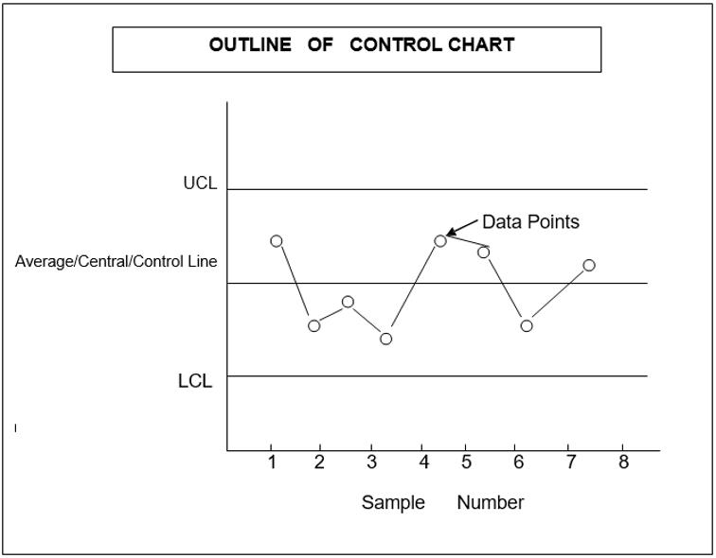
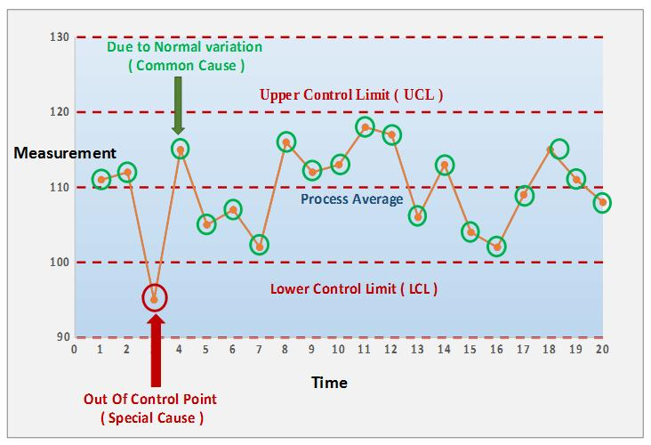
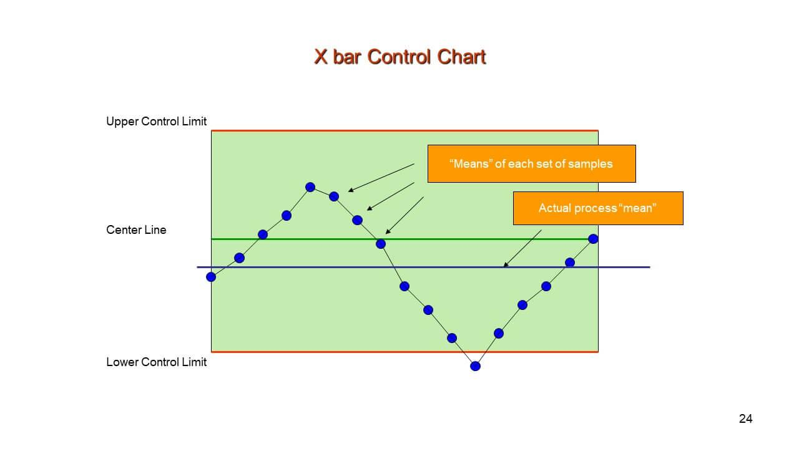
6

✅ Simple Definition:
A control chart is a graph used to monitor a process over time
👉 It helps answer:
“Process stable hai ya problem hai?”

📌 What is SPC (Statistical Process Control)?
👉 SPC means:
Using statistics to control and improve quality
✔ Used in factories
✔ Used in production systems

📊 BASIC COMPONENTS OF CONTROL CHART

🔹 1. CL (Center Line)
👉 Average (Mean) of data

🔹 2. UCL (Upper Control Limit)

🔹 3. LCL (Lower Control Limit)

📐 FORMULA (VERY IMPORTANT)
UCL=Xˉ+3σUCL = \bar{X} + 3\sigmaUCL=Xˉ+3σ
LCL=Xˉ−3σLCL = \bar{X} - 3\sigmaLCL=Xˉ−3σ

✅ Explanation:
- UCL = maximum limit
- LCL = minimum limit
- CL = average

🎯 KEY IDEA
✔ If points are inside limits → process is OK ✅
✔ If points are outside limits → problem exists ❌

📊 TYPES OF CONTROL CHARTS

🔹 1. X-bar Chart
👉 Used for averages

🔹 2. R Chart
👉 Used for range

🔹 3. p Chart
👉 Used for proportion/defects

🔹 4. c Chart
👉 Used for count of defects

📊 EXAMPLE (VERY IMPORTANT)
Data mean = 50
Standard deviation = 5

Step 1: UCL
= 50 + 3(5) = 65

Step 2: LCL
= 50 – 3(5) = 35

👉 So:
- UCL = 65
- CL = 50
- LCL = 35

📊 INTERPRETATION
Situation | Meaning
Inside limits | Process stable ✅
Outside limits | Problem ❌

🧠 IMPORTANT RULES
✔ One point outside → out of control
✔ Many points near limit → warning
✔ Random pattern → normal

🧑‍💻 EXCEL PRACTICAL

Steps:
- Enter data
- Calculate Mean
- Calculate SD
- Compute UCL & LCL
- Insert line chart

Formulas in Excel:
=AVERAGE(A1:A10)
=STDEV(A1:A10)
=Mean + 3*SD
=Mean - 3*SD

🎯 EXAM TIPS
✔ Always write formulas
✔ Draw diagram
✔ Explain CL, UCL, LCL clearly
✔ Give interpretation

🧠 MEMORY TRICK
👉 “3 Sigma Rule”
✔ UCL = +3σ
✔ LCL = -3σ

📊 SOLVED QUESTION

Q: Mean = 100, SD = 10

UCL:
100 + 3(10) = 130

LCL:
100 – 3(10) = 70

🧠 MCQs (EXAM LEVEL)

Q1. Control chart is used for:
A) Decoration
B) Monitoring process ✅

Q2. CL represents:
A) Maximum
B) Average ✅

Q3. UCL formula:
A) Mean + 3σ ✅

Q4. LCL formula:
A) Mean – 3σ ✅

Q5. If point outside limit:
A) OK
B) Problem ✅

Q6. SPC stands for:
A) Statistical Process Control ✅

Q7. X-bar chart shows:
A) Average ✅

Q8. R chart shows:
A) Range ✅

Q9. p chart shows:
A) Proportion ✅

Q10. Sigma means:
A) Mean
B) Standard deviation ✅

✏️ SHORT QUESTIONS (WITH ANSWERS)

Q1. What is control chart?
👉 Graph to monitor process

Q2. What is CL?
👉 Mean of data

Q3. What is UCL?
👉 Upper limit

Q4. What is LCL?
👉 Lower limit

Q5. What is SPC?
👉 Statistical Process Control

📝 LONG QUESTIONS (WITH ANSWERS)

Q1. Explain control chart
👉 Control chart shows process performance using:
- CL
- UCL
- LCL

Q2. Explain types of control charts
👉 Types:
- X-bar
- R
- p
- c

Q3. Explain importance of control charts
👉 Helps:
- Detect problems
- Maintain quality
- Improve process

🎯 PRACTICAL QUESTION
👉 Given data:
Find:
- Mean
- SD
- UCL
- LCL

🎓 FINAL REVISION
✔ CL = Mean
✔ UCL = Mean + 3σ
✔ LCL = Mean – 3σ
✔ Inside = OK
✔ Outside = Problem

📘 CHAPTER 6: CORRELATION & REGRESSION

📊 What is Correlation?
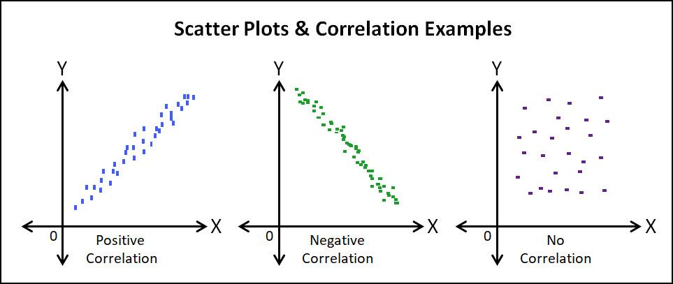
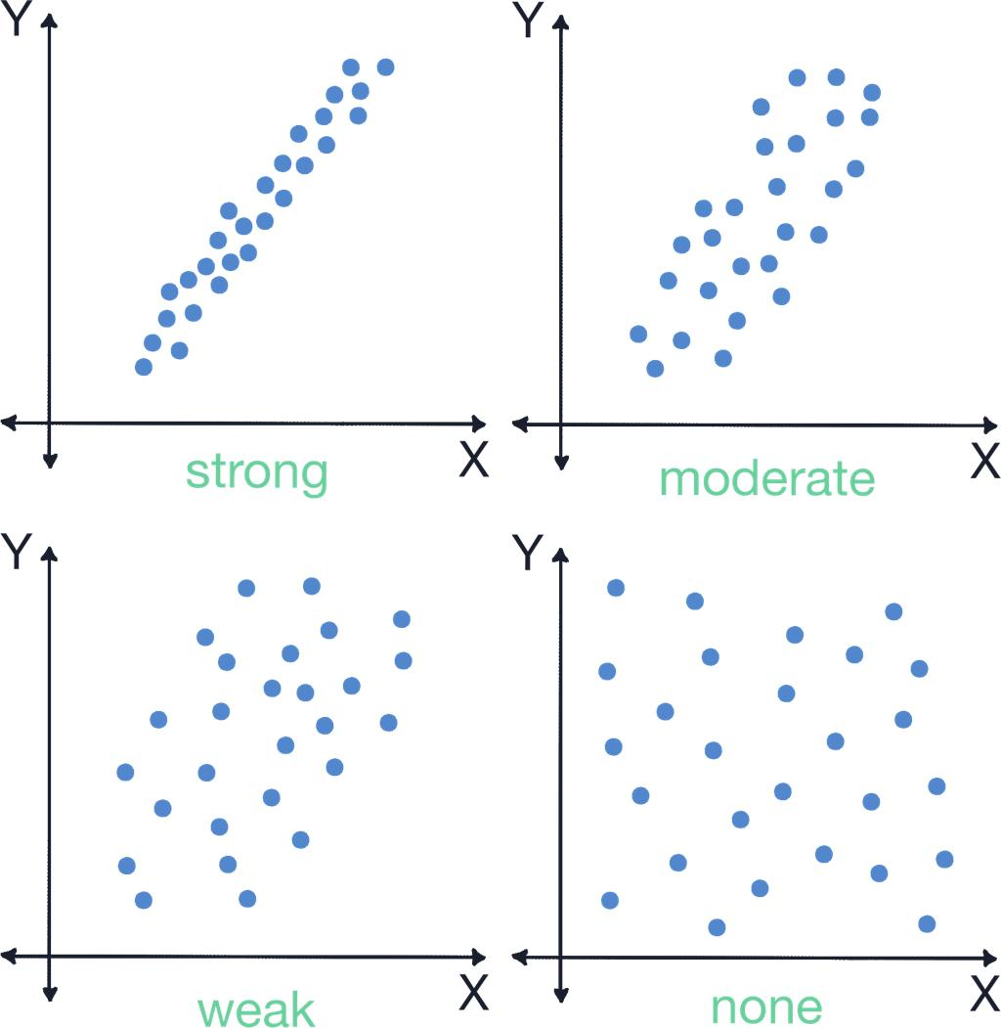
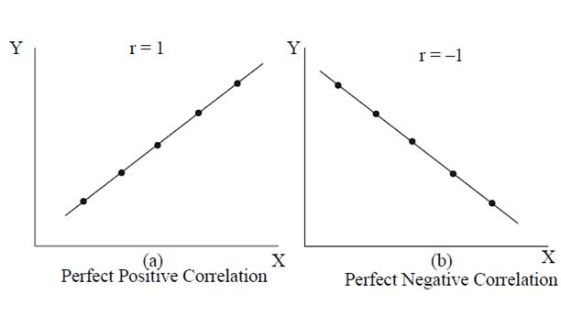
5

✅ Simple Definition:
Correlation shows relationship between two variables
👉 It answers:
“Ek cheez badhe to doosri kya karti hai?”

📌 Types of Correlation

🔹 1. Positive Correlation
👉 Both increase together
Example:
- Study ↑ → Marks ↑

🔹 2. Negative Correlation
👉 One increases, other decreases
Example:
- Price ↑ → Demand ↓

🔹 3. Zero Correlation
👉 No relation

📐 Correlation Coefficient (r)

Range:
-1 ≤ r ≤ +1
Value | Meaning
+1 | Perfect positive
0 | No relation
-1 | Perfect negative

🎯 Interpretation
✔ r close to +1 → strong positive
✔ r close to 0 → weak
✔ r close to -1 → strong negative

📊 SCATTER DIAGRAM
👉 Graph of points
✔ Shows relationship visually

🔹 REGRESSION

📊 Definition:
Regression predicts value of one variable using another

📐 Regression Equation:
y=b0+b1xy = b_0 + b_1 xy=b0​+b1​x
b0b_0b0​
b1b_1b1​

📌 Terms:
Term | Meaning
y | Dependent variable
x | Independent variable
b₀ | Intercept
b₁ | Slope

🎯 Simple Meaning:
👉 “If x changes, what will y be?”

📊 EXAMPLE
If:
b₀ = 2
b₁ = 3
Equation:
y = 2 + 3x

If x = 4:
y = 2 + 12 = 14

📊 DIFFERENCE: CORRELATION vs REGRESSION
Correlation | Regression
Measures relationship | Predicts value
r value | Equation

🧑‍💻 EXCEL PRACTICAL (VERY IMPORTANT)

📊 Correlation in Excel
=CORREL(A1:A10,B1:B10)

📊 Regression in Excel

Steps:
- Go to Data tab
- Click Data Analysis
- Select Regression
- Input X and Y range
- Click OK

📊 Output:
✔ Coefficients
✔ R value
✔ Equation

🎯 EXAM TIPS
✔ Always write range of r
✔ Draw scatter diagram
✔ Explain positive/negative clearly
✔ Practice regression equation

🧠 MEMORY TRICKS
✔ Correlation = Relationship
✔ Regression = Prediction
👉 “r tells strength, equation tells future”

📊 SOLVED NUMERICAL

Given:
x = 2, y = 8
Equation:
y = 2 + 3x

Solution:
y = 2 + 3(2)
y = 2 + 6 = 8

🧠 MCQs (EXAM LEVEL)

Q1. Correlation shows:
A) Prediction
B) Relationship ✅

Q2. Range of r:
A) 0 to 1
B) -1 to +1 ✅

Q3. r = 1 means:
A) Weak
B) Perfect positive ✅

Q4. r = 0 means:
A) No relation ✅

Q5. Regression is used for:
A) Prediction ✅

Q6. Equation is:
A) y = b₀ + b₁x ✅

Q7. Positive correlation:
A) Opposite
B) Same direction ✅

Q8. Negative correlation:
A) Same
B) Opposite ✅

Q9. Scatter diagram shows:
A) Table
B) Relationship visually ✅

Q10. b₁ is:
A) Intercept
B) Slope ✅

✏️ SHORT QUESTIONS (WITH ANSWERS)

Q1. Define correlation
👉 Relationship between variables

Q2. Define regression
👉 Prediction of variable

Q3. What is r?
👉 Correlation coefficient

Q4. What is scatter diagram?
👉 Graph showing relationship

📝 LONG QUESTIONS (WITH ANSWERS)

Q1. Explain correlation
👉 Types:
- Positive
- Negative
- Zero

Q2. Explain regression
👉 Equation:
y = b₀ + b₁x
Used for prediction

Q3. Difference between correlation & regression
👉 Correlation → relationship
👉 Regression → prediction

🎯 PRACTICAL QUESTION
👉 Given X and Y data:
- Find correlation
- Find regression

🎓 FINAL REVISION
✔ r range = -1 to +1
✔ Positive = same direction
✔ Negative = opposite
✔ Regression = prediction
✔ Equation = y = b₀ + b₁x

📘 CHAPTER 7: HYPOTHESIS TESTING

📊 What is Hypothesis Testing?
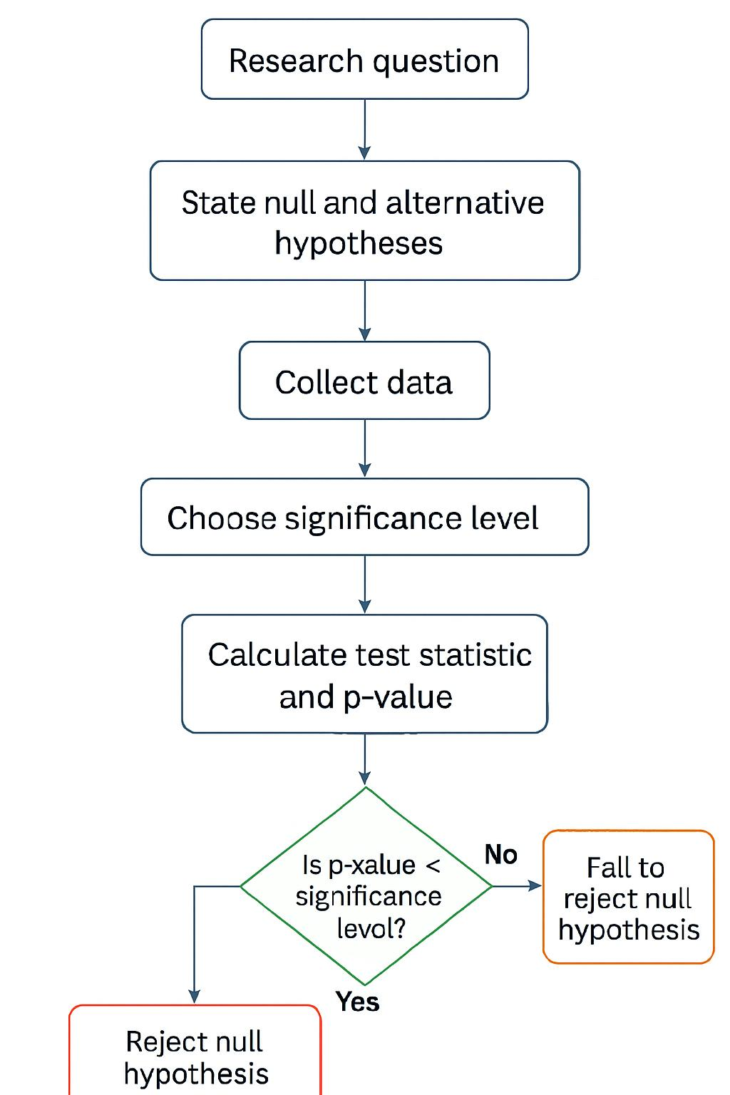
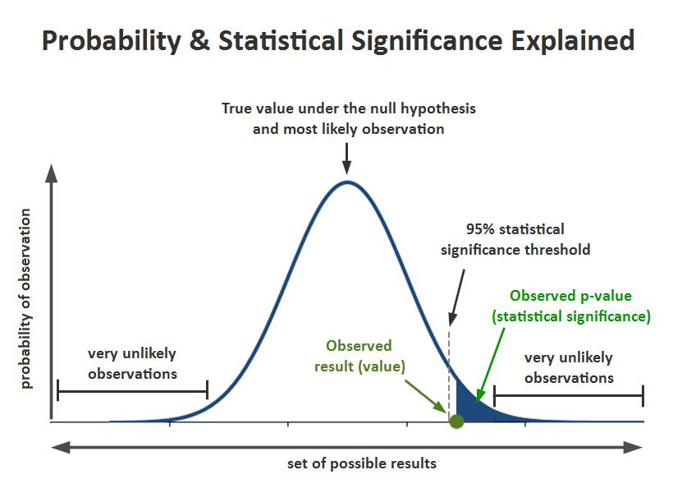
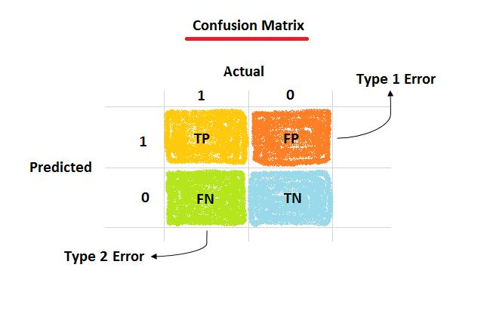
6

✅ Simple Definition:
Hypothesis testing is a method to make decisions using data
👉 It answers:
“Claim sahi hai ya galat?”

📌 BASIC TERMS (VERY IMPORTANT)

🔹 1. Null Hypothesis (H₀)
👉 Default statement (no change / no effect)
Example:
H₀: Mean = 50

🔹 2. Alternative Hypothesis (H₁)
👉 Opposite of H₀
Example:
H₁: Mean ≠ 50

🎯 Simple Understanding:
👉 H₀ = “Nothing special”
👉 H₁ = “Something is happening”

📊 TYPES OF TESTS

🔹 1. One-Tailed Test
👉 Direction matters
Example:
- Mean > 50

🔹 2. Two-Tailed Test
👉 Any difference
Example:
- Mean ≠ 50

📊 SIGNIFICANCE LEVEL (α)
👉 Probability of error
Common values:
- 0.05
- 0.01

📊 p-VALUE (VERY IMPORTANT)

✅ Definition:
p-value = probability of getting result

🎯 Decision Rule:
✔ p ≤ 0.05 → Reject H₀ ❌
✔ p > 0.05 → Accept H₀ ✅

🧠 Trick:
👉 “Small p = Reject H₀”

❌ ERRORS IN HYPOTHESIS TESTING

🔹 Type I Error
👉 Reject true H₀

🔹 Type II Error
👉 Accept false H₀

📊 Table:
Decision | Reality | Error
Reject H₀ | True | Type I ❌
Accept H₀ | False | Type II ❌

📊 STEPS OF HYPOTHESIS TESTING

Step 1:
State H₀ and H₁

Step 2:
Choose significance level (α)

Step 3:
Calculate test statistic

Step 4:
Find p-value

Step 5:
Make decision

📊 EXAMPLE (VERY IMPORTANT)

Given:
Claim: Mean = 50
H₀: Mean = 50
H₁: Mean ≠ 50
p-value = 0.03

Decision:
0.03 < 0.05 → Reject H₀ ❌
👉 Conclusion: Claim is wrong

🧑‍💻 EXCEL PRACTICAL

Steps:
- Enter data
- Go to Data tab
- Click Data Analysis
- Select t-test
- Check p-value

🎯 EXAM TIPS
✔ Always write H₀ first
✔ Learn p-value rule
✔ Understand errors clearly
✔ Practice examples

🧠 MEMORY TRICKS
✔ H₀ = No effect
✔ H₁ = Effect
👉 “Small p = Reject”

🧠 MCQs (EXAM LEVEL)

Q1. H₀ means:
A) Alternative
B) Null hypothesis ✅

Q2. H₁ means:
A) Alternative hypothesis ✅

Q3. p-value < 0.05:
A) Accept
B) Reject H₀ ✅

Q4. Type I error:
A) Reject true H₀ ✅

Q5. Type II error:
A) Accept false H₀ ✅

Q6. α means:
A) Significance level ✅

Q7. One-tailed test:
A) Directional ✅

Q8. Two-tailed test:
A) Non-directional ✅

Q9. Hypothesis testing is:
A) Guess
B) Statistical decision method ✅

Q10. Small p-value means:
A) Accept
B) Reject ✅

✏️ SHORT QUESTIONS (WITH ANSWERS)

Q1. What is hypothesis?
👉 Statement about population

Q2. What is H₀?
👉 Null hypothesis

Q3. What is p-value?
👉 Probability of result

Q4. Define Type I error
👉 Reject true H₀

Q5. Define Type II error
👉 Accept false H₀

📝 LONG QUESTIONS (WITH ANSWERS)

Q1. Explain hypothesis testing
👉 Steps:
- H₀ & H₁
- α
- Test statistic
- p-value
- Decision

Q2. Explain errors
👉 Type I → reject true
👉 Type II → accept false

Q3. Explain p-value
👉 Used to decide whether to reject H₀

🎯 PRACTICAL QUESTION
👉 Given data:
- Form hypothesis
- Find p-value
- Make decision

🎓 FINAL REVISION
✔ H₀ = No effect
✔ H₁ = Effect
✔ p ≤ 0.05 → Reject
✔ Type I = Reject true
✔ Type II = Accept false

📘 CHAPTER 8: NON-PARAMETRIC TESTS & SPSS

📊 What are Non-Parametric Tests?
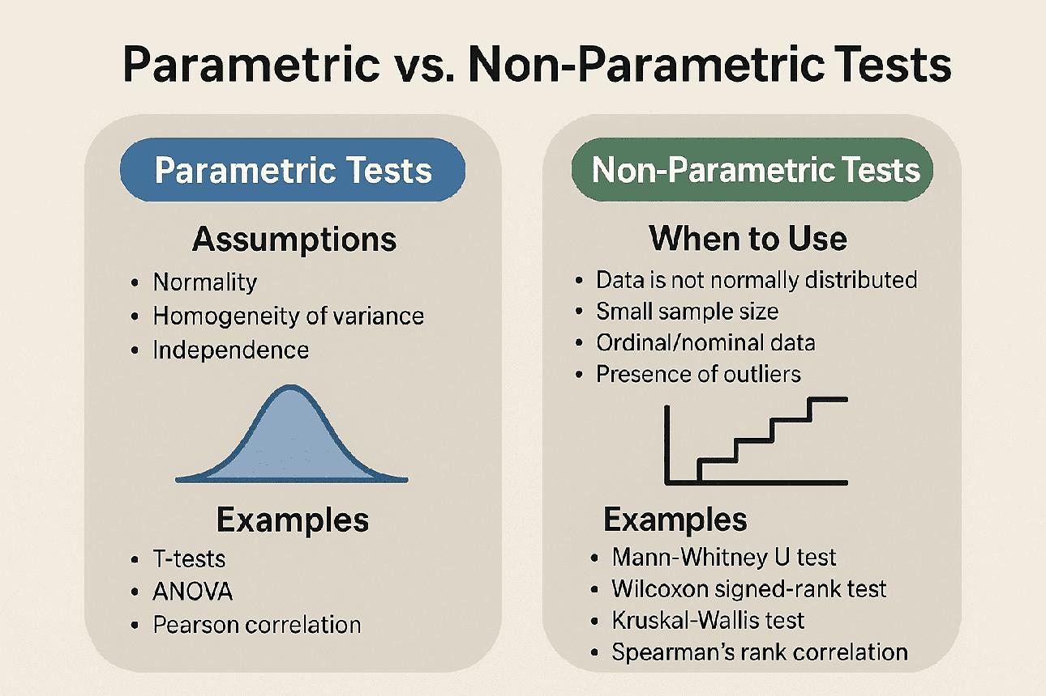
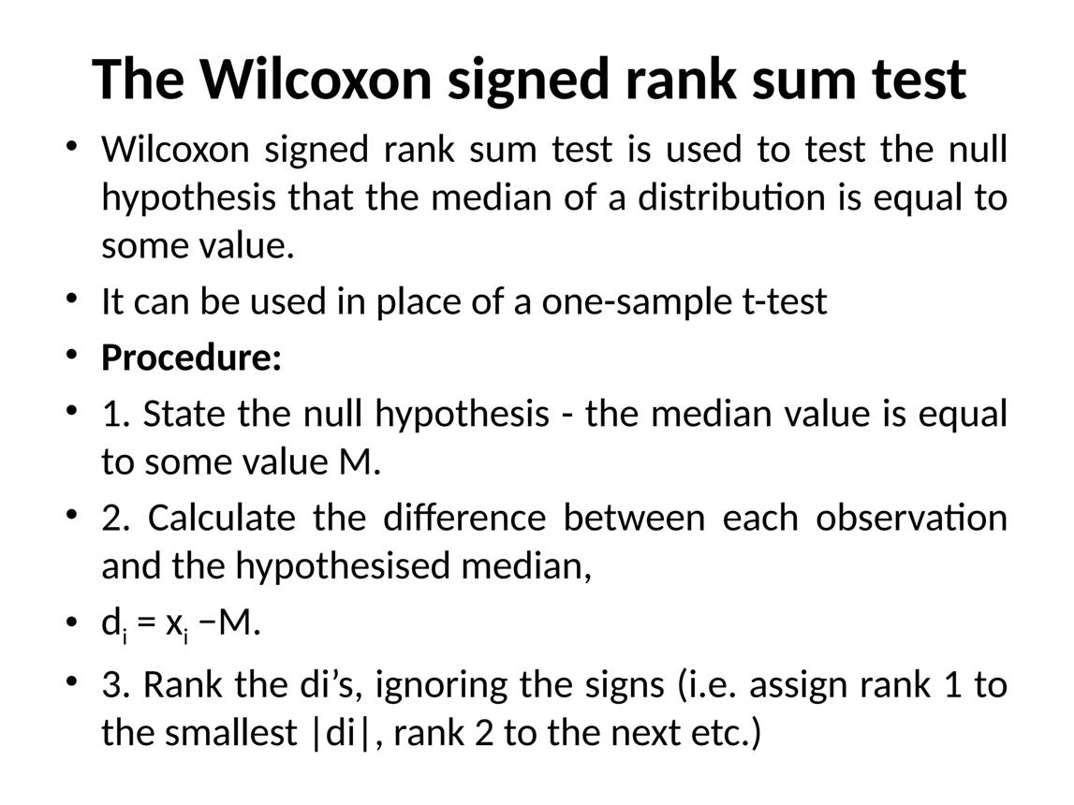
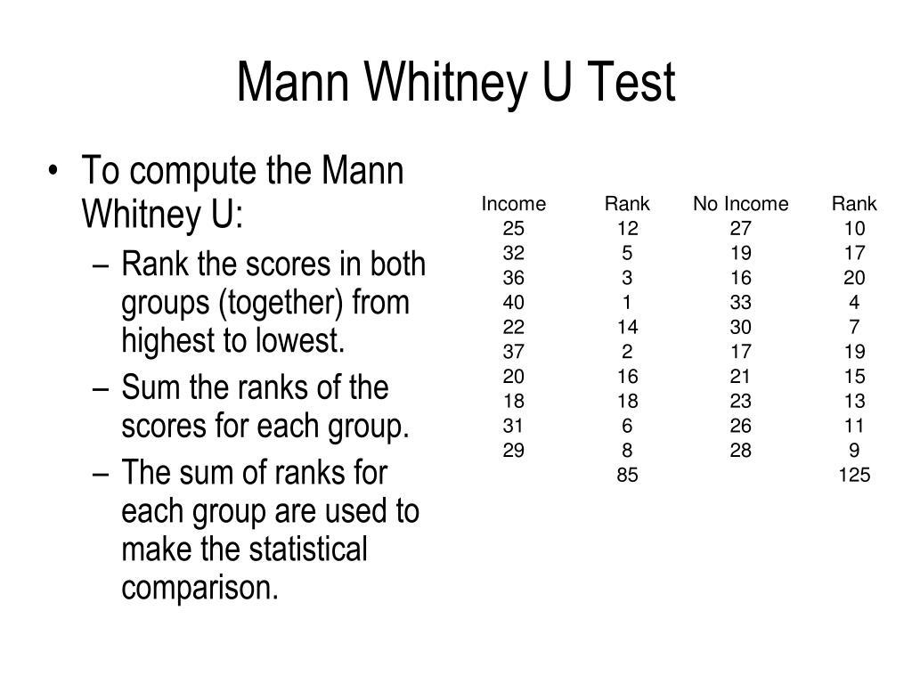
6

✅ Simple Definition:
Non-parametric tests are statistical tests that:
- Do NOT assume normal distribution
- Use ranks instead of actual values
👉 Simple words:
“Data normal na ho → non-parametric use karo”

📌 When to Use?
✔ Small sample size
✔ Non-normal data
✔ Ordinal data (ranking)

📊 TYPES OF NON-PARAMETRIC TESTS

🔹 1. Wilcoxon Signed-Rank Test

✅ Use:
👉 Compare two related samples
Example:
- Before vs After treatment

📊 Idea:
- Convert values into ranks
- Compare differences

🔹 2. Mann–Whitney U Test

✅ Use:
👉 Compare two independent groups
Example:
- Class A vs Class B

📊 Idea:
- Rank all values
- Compare groups

🔹 3. Kruskal–Wallis Test

✅ Use:
👉 Compare more than two groups

📊 PARAMETRIC vs NON-PARAMETRIC
Parametric | Non-Parametric
Normal data | No assumption
Mean used | Rank used
Powerful | Flexible

🧠 MEMORY TRICK
👉 “No Normal → Non-Parametric”

🧑‍💻 SPSS (VERY IMPORTANT)

📊 What is SPSS?

✅ Definition:
SPSS is software used for:
- Data analysis
- Statistical tests

📊 SPSS Interface
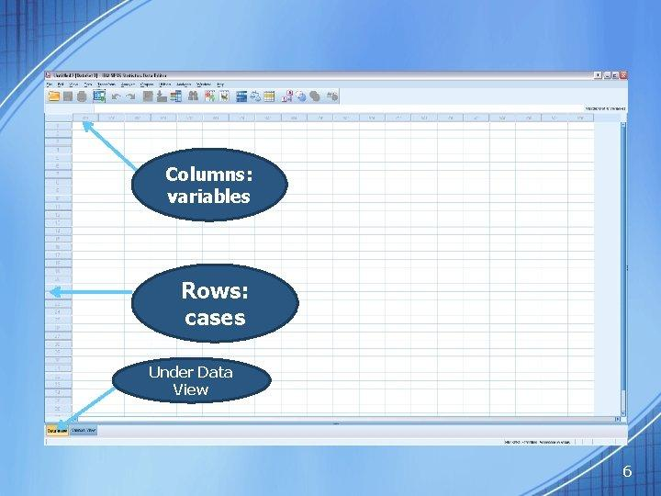
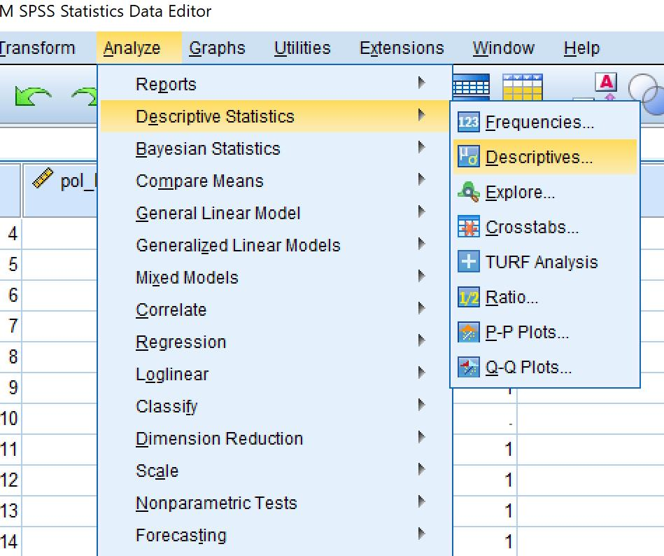
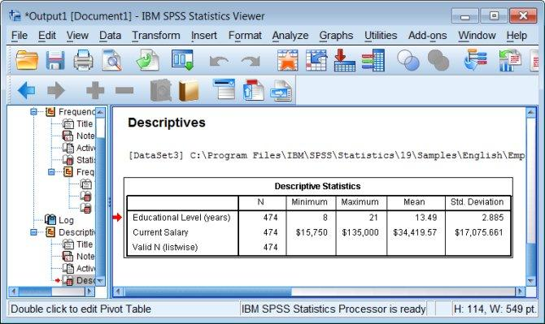
6

📌 Two Main Views

🔹 Data View
👉 Enter data

🔹 Variable View
👉 Define variables

📊 HOW TO USE SPSS (STEP BY STEP)

Step 1:
Open SPSS

Step 2:
Go to Variable View
- Enter variable names

Step 3:
Go to Data View
- Enter data

Step 4:
Click Analyze

Step 5:
Select test:
- Descriptive
- t-test
- Non-parametric

Step 6:
Click OK → Get results

📊 NON-PARAMETRIC TEST IN SPSS

Steps:
- Analyze
- Nonparametric Tests
- Choose test
- Click OK

🎯 EXAM TIPS
✔ Learn when to use each test
✔ Remember rank concept
✔ Practice SPSS steps
✔ Focus on definitions

🧠 MEMORY TRICKS
✔ Wilcoxon → “Before vs After”
✔ Mann-Whitney → “Two groups”
✔ Kruskal → “More groups”

📊 EXAMPLE QUESTION

Q: Compare before & after marks
👉 Use: Wilcoxon test

Q: Compare two classes
👉 Use: Mann-Whitney test

🧠 MCQs (EXAM LEVEL)

Q1. Non-parametric test is used when:
A) Normal data
B) Non-normal data ✅

Q2. Wilcoxon test is for:
A) Two related samples ✅

Q3. Mann-Whitney test is for:
A) Two independent groups ✅

Q4. Kruskal-Wallis test is for:
A) More than two groups ✅

Q5. SPSS is:
A) Hardware
B) Software ✅

Q6. SPSS is used for:
A) Drawing
B) Data analysis ✅

Q7. Data View is used for:
A) Enter data ✅

Q8. Variable View is used for:
A) Define variables ✅

Q9. Non-parametric uses:
A) Mean
B) Rank ✅

Q10. If data not normal:
A) Parametric
B) Non-parametric ✅

✏️ SHORT QUESTIONS (WITH ANSWERS)

Q1. What is non-parametric test?
👉 Test without normal assumption

Q2. What is Wilcoxon test?
👉 Test for related samples

Q3. What is Mann-Whitney test?
👉 Test for two independent groups

Q4. What is SPSS?
👉 Statistical software

📝 LONG QUESTIONS (WITH ANSWERS)

Q1. Explain non-parametric tests
👉 Types:
- Wilcoxon
- Mann-Whitney
- Kruskal-Wallis

Q2. Explain SPSS steps
👉 Steps:
- Enter data
- Analyze
- Select test
- Get results

Q3. Difference between parametric & non-parametric
👉 Parametric → normal
👉 Non-parametric → no assumption

(IMPORTANT – 30+)

🔹 Chapter 1–2 (Excel + Central Tendency)
- Excel file is called:
👉 Workbook ✅
- Cell reference consists of:
👉 Column + Row ✅
- Formula must start with:
👉 = sign ✅
- Mean formula is:
👉 Sum / n ✅
- Median requires:
👉 Sorting data ✅
- Mode is:
👉 Most frequent value ✅
- Which is affected by outliers?
👉 Mean ✅
- Excel function for mean:
👉 =AVERAGE() ✅

🔹 Chapter 3 (Dispersion)
- Range formula:
👉 Max – Min ✅
- Variance uses:
👉 Squared differences ✅
- Standard deviation is:
👉 Square root of variance ✅
- Small SD means:
👉 Data close ✅
- CV is:
👉 Percentage variation ✅

🔹 Chapter 4 (Graphs)
- Histogram has:
👉 No gaps ✅
- Bar chart has:
👉 Gaps ✅
- Pie chart shows:
👉 Percentage ✅
- Ogive is:
👉 Cumulative graph ✅

🔹 Chapter 5 (Control Charts)
- CL represents:
👉 Mean ✅
- UCL formula:
👉 Mean + 3σ ✅
- LCL formula:
👉 Mean – 3σ ✅
- Outside limits means:
👉 Process out of control ✅

🔹 Chapter 6 (Correlation & Regression)
- Range of r:
👉 -1 to +1 ✅
- r = 0 means:
👉 No correlation ✅
- Regression is used for:
👉 Prediction ✅
- Equation:
👉 y = b₀ + b₁x ✅

🔹 Chapter 7 (Hypothesis)
- H₀ means:
👉 Null hypothesis ✅
- p < 0.05:
👉 Reject H₀ ✅
- Type I error:
👉 Reject true H₀ ✅

🔹 Chapter 8 (SPSS)
- SPSS is:
👉 Statistical software ✅
- Wilcoxon test is for:
👉 Related samples ✅

📘 SECTION B: SHORT QUESTIONS (IMPORTANT)

🔹 With Answers

Q1. Define Mean
👉 Average of data

Q2. Define Median
👉 Middle value

Q3. Define Range
👉 Difference between max and min

Q4. Define Standard Deviation
👉 Measure of spread

Q5. What is histogram?
👉 Graph without gaps

Q6. What is correlation?
👉 Relationship between variables

Q7. What is regression?
👉 Prediction method

Q8. What is H₀?
👉 Null hypothesis

Q9. What is p-value?
👉 Probability value

Q10. What is SPSS?
👉 Statistical software

📘 SECTION C: LONG QUESTIONS (IMPORTANT)

🔹 Q1. Explain Mean, Median, Mode
👉 Mean = Average
👉 Median = Middle
👉 Mode = Most frequent

🔹 Q2. Explain Measures of Dispersion
👉 Includes:
- Range
- Variance
- SD
- IQR
- CV

🔹 Q3. Explain Control Chart
👉 Components:
- CL
- UCL
- LCL
👉 Used for quality control

🔹 Q4. Explain Correlation & Regression
👉 Correlation → relationship
👉 Regression → prediction

🔹 Q5. Explain Hypothesis Testing
👉 Steps:
- H₀ & H₁
- p-value
- Decision

🔹 Q6. Explain Non-Parametric Tests
👉 Wilcoxon
👉 Mann-Whitney
👉 Kruskal-Wallis

📘 SECTION D: NUMERICAL QUESTIONS (VERY IMPORTANT)

🔹 Q1. Mean
Data: 2, 4, 6
👉 Mean = (2+4+6)/3 = 4

🔹 Q2. Median
Data: 1, 3, 5
👉 Median = 3

🔹 Q3. Range
Data: 5, 10, 15
👉 Range = 15 – 5 = 10

🔹 Q4. SD (Simple)
Data: 2, 4, 6
👉 SD = 2

🔹 Q5. Control Chart
Mean = 50, SD = 5
👉 UCL = 65
👉 LCL = 35

🔹 Q6. Regression
y = 2 + 3x
x = 4
👉 y = 14

